SkillMesh

Final Year Project

Session 2020-2024

A project submitted in partial fulfillment of the degree of

BS in Computer Science


Department of Computer Science
Faculty of Computer Science & Information Technology
The Superior University, Lahore

Fall 2023

Type (Nature of project) |  |  | [ ] Development [ ] Research [ ] R&D
Area of specialization |  |  | Blockchain
FYP ID |  |  | FYP-BCSM-F23-038
Project Group Members
Sr.# | Reg. # | Student Name |  | Email ID | *Signature
(i) |  | Haseeb Ahmed |  | BCSM-F20-079@superior.edu.pk
(ii) |  | Sufyan Ahmed |  | BCSM-F20-216@superior.edu.pk
(iii) |  | Ali Hassan |  | BCSM-F20-087@superior.edu.pk

*The candidates confirm that the work submitted is their own and appropriate credit has been given where reference has been made to work of others

Plagiarism Free Certificate
This is to certify that, I ________ S/D of Muhammad Siddique, group leader of FYP under registration no ______________________________at Software Engineering Department, The Superior College, Lahore. I declare that my FYP report is checked by my supervisor.

Date: Name of Group Leader: _________________ Signature: _____________
Name of Supervisor: Dr. ABC Co-Supervisor: Mr. XYZ
Designation: Lecturer Designation: Associate Professor
Signature: ________________ Signature: _________________

HoD: Dr. Tehreem Masood
Signature: _______________

[SkillMesh]

Change Record
Author(s) | Version | Date | Notes | Supervisor’s Signature
 | 1.0 |  | <Original Draft>
 |  |  | <Changes Based on Feedback from Supervisor>
 |  |  | <Changes Based on Feedback From Faculty>
 |  |  | <Added Project Plan>
 |  |  | <Changes Based on Feedback from Supervisor>

APPROVAL
Project Supervisor
Comments: ___________________________________________________________________
_____________________________________________________________________________
Name:______________________________
Date:_______________________________ | Signature:__________________________

Project Manager
Comments: ___________________________________________________________________
_____________________________________________________________________________
Date:_______________________________ | Signature:__________________________

Head of the Department
Comments: ___________________________________________________________________
_____________________________________________________________________________
Date:_______________________________ | Signature:__________________________

Dedication

To the innovators and collaborators who strive to bridge the gap between skills and opportunities, this work is dedicated. SkillMesh embodies the spirit of decentralized finance, leveraging blockchain and smart contracts to create a global marketplace where talents meet needs. To the service providers who craft excellence and the seekers who envision possibilities, your dedication fuels the engine of SkillMesh. May this platform be a testament to the power of connectivity and the boundless potential when skills find their perfect match.

Acknowledgements

I express sincere gratitude to our supervisor for actively contributing to our project. The hard work and dedication of our team members towards this technology have been commendable, resulting in the successful production of significant project outcomes.

Executive Summary
SkillMesh is a DeFi project that aims to connect individuals who have specific skills and expertise with those who are seeking those skills, all while utilizing blockchain technology and smart contracts to facilitate secure, transparent, and efficient interactions.
The platform serves as a marketplace where users can offer their skills, services, and expertise to a global audience. Users who possess skills in areas such as graphic design, programming, writing, tutoring, translation, and more can create profiles and list the services they offer.
Service Providers: These are individuals with specific skills and services to offer. They create profiles highlighting their experience, portfolio, pricing, and availability. Service providers can set their rates in a preferred cryptocurrency or token.
Service Seekers: These are individuals or organizations seeking particular skills or services. They can search the platform for relevant service providers, view their profiles, and engage them for their required tasks.

Table of Contents
Dedication iv
Acknowledgements v
Executive Summary vi
Table of Contents vii
List of Figures ix
List of Tables x
Chapter 1 1
Introduction 1
1.1. Background 2
1.2. Motivations and Challenges 2
1.3. Goals and Objectives 2
1.4. Literature Review/Existing Solutions 2
1.5. Gap Analysis 2
1.6. Proposed Solution 2
1.7. Project Plan 3
1.7.1. Work Breakdown Structure 3
1.7.2. Roles & Responsibility Matrix 3
1.7.3. Gantt Chart 3
1.8. Report Outline 3
Chapter 2 4
Software Requirement Specifications 4
2.1. Introduction 5
2.1.1. Purpose 5
2.1.2. Document Conventions 5
2.1.3. Intended Audience and Reading Suggestions 5
2.1.4. Product Scope 5
2.1.5. References 6
2.2. Overall Description 6
2.2.1. Product Perspective 6
2.2.2. Product Functions 6
2.2.3. User Classes and Characteristics 6
2.2.4. Operating Environment 7
2.2.5. Design and Implementation Constraints 7
2.2.6. User Documentation 7
2.2.7. Assumptions and Dependencies 7
2.3. External Interface Requirements 8
2.3.1. User Interfaces 8
2.3.2. Hardware Interfaces 8
2.3.3. Software Interfaces 8
2.3.4. Communications Interfaces 9
2.4. System Features 9
2.4.1. System Feature 1 9
2.4.1.1. Description and Priority 9
2.4.1.2. Stimulus/Response Sequences 9
2.4.1.3. Functional Requirements 9
2.4.2. System Feature 2 10
2.4.2.1. Description and Priority 10
2.4.2.2. Stimulus/Response Sequences 10
2.4.2.3. Functional Requirements 10
2.4.3. System Feature 3 (and so on) 11
2.5. Other Nonfunctional Requirements 11
2.5.1. Performance Requirements 11
2.5.2. Safety Requirements 11
2.5.3. Security Requirements 12
2.5.4. Software Quality Attributes 12
2.5.5. Business Rules 12
2.6. Other Requirements 12
Chapter 3 13
Use Case Analysis 13
3.1. Use Case Model 14
3.2. Fully Dressed Use Cases 14
Chapter 4 15
System Design 15
4.1. Architecture Diagram 16
4.2. Domain Model 16
4.3. Entity Relationship Diagram with data dictionary 16
4.4. Class Diagram 17
4.5. Sequence / Collaboration Diagram 17
4.6. Operation contracts 17
4.7. Activity Diagram 18
4.8. State Transition Diagram 18
4.9. Component Diagram 18
4.10. Deployment Diagram 19
4.11. Data Flow diagram [only if structured approach is used - Level 0 and 1] 19
Chapter 5 20
Implementation 20
5.1. Important Flow Control/Pseudo codes 21
5.2. Components, Libraries, Web Services and stubs 21
5.3. Deployment Environment 21
5.4. Tools and Techniques 22
5.5. Best Practices / Coding Standards 22
5.6. Version Control 22
Appendices 23
Appendix A: Information / Promotional Material 24
Reference and Bibliography 27
Index 29

List of Figures

1.1 Caption of first figure of first chapter 6
1.2 Caption of second figure of first chapter 7
2.1 Caption of first figure of second chapter 14
2.2 Caption of second figure of second chapter 22
2.3 Caption of third figure of second chapter 26
5.1 Caption of first figure of fifth chapter 49
5.2 Caption of second figure of fifth chapter 49

List of Tables

1.1 label of first table of first chapter 6
1.2 label of second table of first chapter 7
2.1 label of first table of second chapter 14
2.2 label of second table of second chapter 22
2.3 label of third table of second chapter 26
5.1 label of first table of fifth chapter 49
5.2 label of second table of fifth chapter 49

Chapter 1

Introduction

Chapter 1: Introduction
SkillMesh serve as digital marketplaces connecting businesses with freelance professionals globally. Their primary purpose is to enable access to a diverse talent pool, offering specialized skills for various projects and tasks. This platform promotes cost-efficiency, flexibility, and streamlined matchmaking, making it easier for both businesses and freelancers to find the right opportunities and talents, fostering a dynamic and interconnected gig economy. It is a decentralized platform and comes under the category of DeFi (Decentralized Finance).

Background
Freelancing websites have transformed the traditional employment landscape by leveraging the power of the internet to connect freelancers with clients seeking a diverse array of skills and services. Emerging in the late 1990s, platforms like Elance and oDesk paved the way for the gig economy, offering a global marketplace where freelancers could showcase their talents. The 2010s witnessed a surge in specialized platforms like Fiverr and Toptal, catering to specific industries. The globalization of work became a prominent feature, allowing businesses to access talent worldwide. The 2020s brought challenges and opportunities, with the COVID-19 pandemic accelerating the demand for remote work. Freelancing websites continue to evolve, addressing issues like payment security and incorporating technologies such as blockchain. These platforms play a vital role in shaping the future of work, providing flexibility for freelancers and a global talent pool for businesses.

Motivations and Challenges
Enhanced Security and Trust: Decentralized platforms built on blockchain which offers increased security through transparent and immutable transaction records. This instills trust among users, ensuring fair payments and reducing fraud or manipulation.
Lower Fees and Fair Payment: By eliminating intermediaries, decentralized platforms can potentially reduce fees associated with transactions. Smart contracts and decentralized systems can automate payment processes, ensuring fair and timely remuneration for freelancers.
Reduced Centralized Authority: Decentralization reduces dependency on a single controlling authority, promoting a more democratic and fair ecosystem where decisions are collectively made and executed.
Usability: Ensuring a user-friendly interface is crucial for widespread adoption.
Quality Control: Maintaining a high standard of work quality and preventing low-quality services from being offered is important.
Regulatory Considerations: Depending on the platform's jurisdiction and users' locations, there may be regulatory challenges to address.
Dispute Resolution: Implementing an effective and fair dispute resolution mechanism is necessary for maintaining user trust.

Goals and Objectives
A decentralized freelancing website aims to revolutionize the gig economy by leveraging blockchain technology and decentralized principles to create a platform that prioritizes transparency, security, and fairness for both freelancers and clients. The primary goals and objectives of such a platform include:

- Blockchain Security and Transparency: Implementing blockchain ensures secure and transparent transactions. Smart contracts, which are self-executing contracts with the terms of the agreement directly written into code, can automate payments and provide a trustworthy system for freelancers to receive compensation for their work.

- Reduced Intermediary Dependency: Decentralized freelancing platforms seek to minimize reliance on intermediaries, eliminating the need for traditional banking systems or third-party payment processors. This can lead to lower transaction fees and faster payment processing times, benefitting both freelancers and clients.

- Community Governance: Decentralized platforms often incorporate community-driven governance models, allowing users to have a say in the decision-making processes. This democratized approach ensures that the platform evolves in a way that aligns with the needs and preferences of its user base.

- Identity Verification and Reputation Systems: Leveraging blockchain for identity verification can enhance security and build trust among users. A decentralized reputation system can allow freelancers to showcase their skills and reliability, helping clients make informed decisions when selecting service providers.

- Global Accessibility: By leveraging blockchain's borderless nature, decentralized freelancing platforms can provide equal opportunities to freelancers from around the world, promoting inclusivity and diversity in the gig economy.

- Resilience to Censorship: Decentralized platforms aim to be resistant to censorship, ensuring that freelancers and clients have the freedom to engage in transactions without being subject to arbitrary restrictions.

Fair Compensation and Dispute Resolution: Smart contracts and decentralized dispute resolution mechanisms can ensure that freelancers receive fair compensation for their work, and conflicts are resolved impartially, fostering a more equitable and trustful freelancing environment

Literature Review/Existing Solutions
Freelancing Platforms are charging too much profit from each order up to 15% to 25% from sellers as well as from buyers. Due to the above problem many users find clients on the platform and deal outside the platform to avoid giving so much profit to the platform.
As the platforms are centralized one of the negative risks is unauthorized access which is a common problem across the centralized platforms.

Gap Analysis
There are multiple Freelancing websites in existence today but all are centralized and charging a lot of fees from sellers as well as from buyers.
Some of the freelancing websites are mentioned in the following table along with the charging fesses.

Platform | Fees for Freelancer | Fees for Clients | Realm
Fiverr | 20% on all orders | 5.5% on all orders  $2.50 additional charge on orders under $75 | Centralized
Upwork | 10% on all orders | 5%  3% for eligible US clients paying via ACH (+$3 per $100) | Centralized
PeoplePerHour | 20% for $0-350  7.5% for $350.01-7,000  3.5% for $7,000+ | 10% + $0.70 | Centralized
Freelancer.com | 10% or $5 (whichever is greater)  10% per milestone for hourly rate jobs | 3% or $3 (whichever is greater)  3% per milestone for hourly rate jobs | Centralized
SkillMesh | 5% on all orders | No charges | Decentralized

Proposed Solution
In SkillMesh we will only charge 5% form the sellers and nothing from the buyers.
As our platform is decentralized we use digital wallets to get access to the platform result in the elimination of negative risk of unauthorized access to the account.

Project Plan
The SkillMesh website project has been carefully designed to use modern technology in order to provide a strong and safe platform for freelancers. The frontend development will be driven by Next.js, ensuring a responsive and engaging user interface. On the backend, the combination of Node.js and Express.js will provide a powerful and scalable foundation. MongoDB is chosen as the database solution, offering flexibility and efficiency in managing data. To fortify the platform's security and transparency, blockchain technology will be seamlessly integrated, utilizing smart contracts for secure and verifiable transactions. This comprehensive technological stack aims to create a seamless and innovative user experience for both freelancers and clients within the decentralized SkillMesh ecosystem.

Work Breakdown Structure

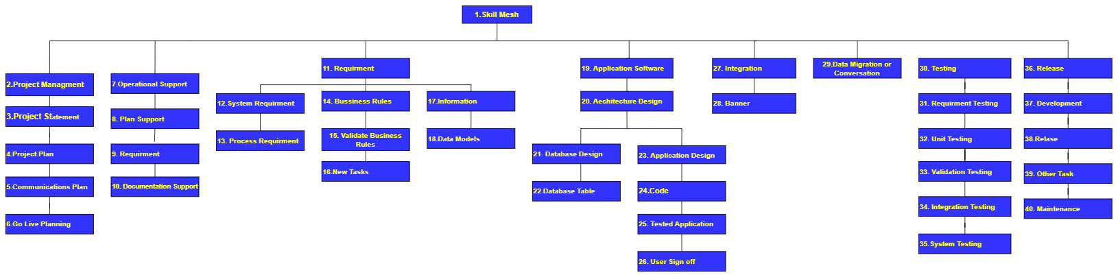

Roles & Responsibility Matrix
The purpose of the roles & responsibility matrix is to identify who will do what.
WBS # | WBS Deliverable | Activity # | Activity to Complete the Deliverable | Duration  (# of Days) | Responsible Team Member(s) & Role(s)
01 | Gather requirements | 1 | Gather data from the Research paper | 15 | Ali Hassan
02 | Analysis for project | 2 | Understand the user's need | 6 | Ali Hassan  Haseeb Ahmed
03 | UI/UX Design | 3 | How does the website look like | 30 | Haseeb Ahmed
04 | Front–End Development | 4 | Building a Website | 15 | Ali Hassan  Haseeb Ahmed  Sufyan Ahmed
05 | Back–End Development | 5 | NodeJs, ExpressJs, MongoDB | 55 | Sufyan Ahmed
06 | Blockchain | 6 | Solidity | 15 | Sufyan Ahmed Haseeb Ahmed
07 | Testing and Debugging | 7 | Test Module | 15 | Ali Hassan  Haseeb Ahmed
08 | Deployment | 8 | Deploying our website | 10 | Ali Hassan  Haseeb Ahmed  Sufyan Ahmed
09 | Documentation | 9 | Final Documentation | 15 | Ali Hassan  Haseeb Ahmed

Gantt chart
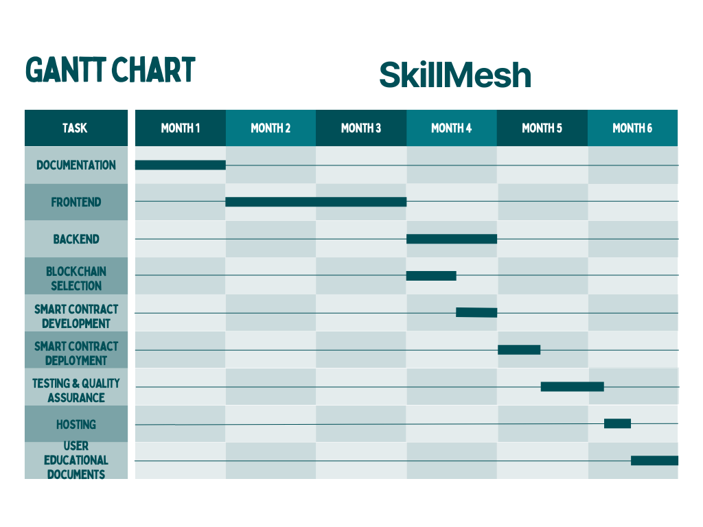

Report Outline
SkillMesh, a revolutionary decentralized application, is poised to redefine the freelancing landscape by leveraging cutting-edge technologies. By integrating blockchain and smart contract capabilities on the Ethereum platform, SkillMesh ensures secure and transparent transactions. The technology stack, comprising NextJs, MongoDB, Tailwind CSS, Sass, Solidity, Node.js, Express.js, and Typescript, underscores a commitment to robust and scalable development.

The platform's unique features include user-friendly account creation, seller account management, gig creation, and wish-listing functionalities. Its search mechanism allows buyers to seamlessly navigate through categories and subcategories, selecting services that align with their needs.

SkillMesh stands out by charging a nominal 5% fee from both sellers and buyers, a transparent and fair model for sustaining the platform.

As a Software Engineer, this report outline serves as a comprehensive roadmap, encapsulating the project's architecture, design principles, database schema, smart contract implementation, testing strategies, security measures, performance optimization, deployment processes, and ongoing maintenance plans. Through this meticulous approach, SkillMesh aims to deliver a seamless and secure freelancing experience while pushing the boundaries of decentralized applications in the digital economy.

Empathy Map
Says: Users express satisfaction with SkillMesh transparent and fair fee model, acknowledging the platform's commitment to a decentralized approach. Positive comments include appreciation for the nominal 5% fee from both sellers and buyers, highlighting the appeal of SkillMesh innovative and equitable pricing structure. | Thinks: Users recognize the advantages of blockchain technology for secure and transparent transactions on SkillMesh. They contemplate the potential impact of decentralization on usability and governance effectiveness. Questions arise regarding how the platform compares to centralized alternatives in terms of user experience and whether the claimed resilience to censorship holds true.
Does: SkillMesh users engage confidently in transactions, exploring services with ease through the efficient search mechanism. They actively participate in the platform's community-driven governance, expressing a desire to have a say in decision-making processes. Users are motivated to verify their identity and build a reliable reputation within the decentralized system. | Feel: Users feel empowered by SkillMesh commitment to transparency, security, and fairness. There is a sense of trust in the platform's unique 5% fee structure for both sellers and buyers. However, concerns linger about the impact of decentralization on usability and the effectiveness of governance and dispute resolution mechanisms, indicating a need for clear communication and reassurance from the platform.

Chapter 2

Software Requirement Specifications

Chapter 2: Software Requirement Specifications

Introduction

Purpose

The SRS outlines the requirements for the entire decentralized freelancing platform. This includes all the core functionalities and features essential to the operation and performance of the platform. The system covered by this SRS represents the entire ecosystem that facilitates interactions between freelancers and clients through a decentralized, blockchain-based network.

Document Conventions

The First Letter of my new paragraph is Capital because it’s showing up the new paragraph starting from here and the only more thing I implemented here. That’s one is Bold the word. Where I did Bold the word, It means that’s word is more important in this paragraph.

Intended Audience and Reading Suggestions
Intended Audience:

- Developers: Developers will find detailed information on the technical architecture of the decentralized freelancing platform, including blockchain integration, smart contract implementation, and any specific coding requirements. Sections on API documentation, protocols, and data structures will be pertinent to this audience.

- Project Managers: Project managers will be interested in understanding the high-level goals, timelines, and resource requirements for developing and maintaining the decentralized freelancing platform. They should focus on sections outlining project milestones, key deliverables, and dependencies.

- Marketing Staff: Marketing staff will be concerned with promoting the platform and attracting users. Information about the platform's unique selling points, target user demographics, and marketing strategies should be of interest to them. They may also be interested in user acquisition and retention features.

- Users: Users, including freelancers and clients, will want to explore sections related to user experience, onboarding processes, and how the platform ensures the security of their transactions. Information about the token system, identity verification, and dispute resolution will also be relevant.

- Testers: Testers will find guidance on test cases, scenarios, and expected outcomes in sections that detail the platform's functionality. Additionally, information on security testing, performance testing, and user acceptance testing will be crucial for this audience.

- Documentation Writers: Documentation writers will need to focus on sections that describe how to use the platform, including user guides, FAQs, and any troubleshooting information. Clear and concise documentation is essential for users to navigate the platform effectively.

Organization of the Software Requirements Specification (SRS):

- Introduction: The introduction outlines the decentralized freelancing platform's goals, emphasizing its innovative approach with decentralized architecture, blockchain integration, and benefits for freelancers and clients.

- Overall Description: Providing a high-level overview, this section highlights key components like smart contracts, token systems, and user-centric design, showcasing the platform's commitment to transparency, security, and a decentralized economic model.

- External Interface Requirements: Detailing interactions, this section outlines user interfaces, third-party integrations, and blockchain interactions, emphasizing transparency, security measures, and communication channels.

- System Features: This section explores user functionalities such as profile creation, job bidding, and real-time communication, along with features like a decentralized reputation system, transparent feedback, and robust dispute resolution mechanisms.

- Other Non-Functional Requirements: Covering non-functional aspects, this section addresses security standards, performance requirements, user experience considerations, and compliance with regulatory and legal frameworks, ensuring a well-rounded understanding of the platform's overall performance and user satisfaction.

Sequence for Reading:

- All Readers: Start with the Overview section to gain a high-level understanding of the platform's goals and objectives.

- Developers: Proceed to the System Architecture section for technical details.

- Project Managers: Move on to the Project Timeline and Milestones section for information on project planning.

- Marketing Staff: Focus on the Marketing and User Acquisition section to understand strategies for promoting the platform.

- Users: Explore the User Experience and Onboarding section for guidance on using the platform effectively.
- All Readers: Review the Payments section for information on the platform's economic model.

- All Readers: Examine the Security Features section for insights into the platform's security measures.

- Testers: Refer to the Testing Procedures section for details on testing processes.

- Documentation Writers: Finally, review the Documentation Guidelines section to understand how to create effective user documentation.

Product Scope
The product scope of a decentralized freelancing website includes fundamental features essential for its operation. This encompasses user registration and profile management for freelancers, clients, and administrators. It involves the ability for clients to post jobs and projects with search and matchmaking tools to connect the right users. Communication features such as messaging, file sharing, and potentially video conferencing aid collaboration. A secure payment system using blockchain technology ensures transparent, automatic, and secure transactions. Additionally, the platform includes a rating system for users, dispute resolution mechanisms, robust security measures, an administrative backend, a responsive user interface, and adherence to legal and compliance standards in the freelancing industry.

Overall Description

Product Perspective
SkillMesh emerges as an independent and innovative product, distinctly positioned to redefine the paradigm of the gig economy through its decentralized architecture and blockchain-driven functionalities. It is imperative to underscore that SkillMesh is not intended as a substitute for existing systems but rather represents a pioneering, self-contained platform. The genesis of SkillMesh emanates from a strategic imperative to establish a marketplace characterized by heightened security, transparency, and operational efficiency for both service providers and consumers.

SkillMesh operates autonomously, delineating its core functionality from any dependencies on pre-existing systems. Nevertheless, it seamlessly integrates with external components and cutting-edge technologies to elevate its operational prowess.
Major Components:
Frontend (Next.js): Serving as the user interface, this component orchestrates the interaction between discerning users and the platform, ensuring a sophisticated user experience.
Backend (Node.js with Express.js): As the crux of server-side logic, this element adeptly manages incoming requests, orchestrates data processing, and interfaces seamlessly with the database.
Database (MongoDB): This secure and scalable database architecture is instrumental in the storage and retrieval of user profiles, gig details, and transactional data.
Media Management (Cloudinary): A judiciously integrated external service, this component facilitates the seamless storage and retrieval of media files intricately associated with listed gigs.

Blockchain Integration (Solidity): SkillMesh leverages smart contracts on the Ethereum blockchain, ushering in an era of secure and transparent transactions.

User Interface Styling (Tailwind CSS and Chakra UI): These libraries, meticulously employed, contribute to the aesthetic finesse and responsive design integral to the SkillMesh user experience.
Subsystem Interconnections:
The subsystems within SkillMesh are interconnected to ensure seamless operation:
- The frontend communicates with the backend to send and receive user requests.
- The backend interacts with the database to store and retrieve user data, gig information, and transaction details.
- Media management through Cloudinary ensures the efficient handling of images and other media associated with gigs.
- Blockchain integration facilitates secure and automated transactions through smart contracts.

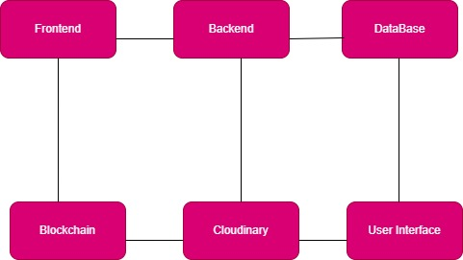

User Classes and Characteristics
- Freelancers:

- Possess specialized skills in various domains.
- Can offer services and create gig listings.
- May include graphic designers, writers, programmers, etc.
- Have profiles showcasing their expertise and work history.
- Clients/Buyers:

- Seek freelancers for specific projects or tasks.
- Can post job listings and place orders for services.
- Evaluate freelancers based on profiles, reviews, and ratings.
- Have the ability to communicate with freelancers.
- Administrators:

- Oversee and manage the overall operation of the platform.
- Have access to administrative tools and controls.
- Monitor user activities and ensure platform integrity.
- Address and resolve issues or disputes.
- Visitors/Unregistered Users:

- Individuals who browse the platform without creating an account.
- Limited access to certain features and functionalities.
- May become registered users by creating an account.
- System Moderators:

- Moderate content and interactions within the platform.
- Ensure compliance with platform guidelines and policies.
- Address reported issues and maintain a positive community.

- Help/Support:

- Provide assistance to users facing issues or queries.
- Respond to inquiries related to platform features or transactions.
- Assist in resolving disputes and ensuring a positive user experience.
- Blockchain Validators:

- Verify and validate transactions on the blockchain.
- Ensure the security and integrity of decentralized operations.
- Play a role in the execution of smart contracts.

Operating Environment
- Web 3.0 Infrastructure:
  - SkillMesh operates in a Web 3.0 environment, characterized by decentralized protocols, peer-to-peer interactions, and blockchain technology.
  - Utilizes decentralized web standards for increased security, transparency, and user control over data.
- Blockchain Network:
  - Relies on a blockchain network, likely Ethereum or a similar decentralized platform, for smart contract execution, secure transactions, and transparent record-keeping.
  - Involves nodes, validators, and smart contract interactions within the blockchain.

- Decentralized Identity Management:
  - Implements decentralized identity solutions based on blockchain for secure and user-controlled identity verification.
  - Users have control over their identity information, enhancing privacy and security.

- Smart Contracts:
  - Smart contracts are deployed on the blockchain to automate and execute agreements between users.
  - They govern processes like payments, order fulfillment, and dispute resolution in a trustless manner.
- Cryptocurrency Integration:
  - Involves the use of cryptocurrencies as a means of payment for services on the platform.
  - Smart contracts handle cryptocurrency transactions securely and transparently.
- Decentralized Storage:
  - Leverages decentralized storage solutions to store and retrieve user data in a distributed manner.
  - Enhances data security, resilience, and availability.
- Web 3.0 Browser Compatibility:
  - Users access SkillMesh using Web 3.0 compatible browsers that support decentralized protocols and blockchain interactions.
  - Ensures a seamless and secure user experience in the decentralized web.

Design and Implementation Constraints

- Blockchain Network Constraints:
  - Constraint: Relies on a specific blockchain network (e.g., Ethereum).
  - Impact: Integration challenges if the chosen blockchain faces scalability or network congestion issues.
- Smart Contract Limitations:
  - Constraint: Smart contracts are used for platform operations.
  - Impact: Changes to smart contracts may require careful consideration and testing to avoid disruptions.
- Cryptocurrency Volatility:
  - Constraint: Uses cryptocurrencies for transactions (e.g., Ether).
  - Impact: Users may be exposed to the volatility of cryptocurrency values, affecting transaction amounts and user behavior.
- Interoperability Challenges:
  - Constraint: Requires interoperability with various blockchain tools and standards.
  - Impact: Ensuring compatibility with different blockchain networks, wallets, and decentralized applications can be complex.
- User Education Requirements:
  - Constraint: Users need to understand blockchain concepts and decentralized operations.
  - Impact: Requires comprehensive educational resources and user support to navigate the decentralized environment.
- Scalability Considerations:
  - Constraint: Blockchain networks may face scalability challenges.
  - Impact: Potential limitations on the number of transactions and user interactions, especially during periods of high demand.
- Security and Auditing:
  - Constraint: Security is paramount due to the use of smart contracts and decentralized infrastructure.
  - Impact: Requires continuous auditing and testing to identify and address security vulnerabilities.
- Web 3.0 Browser Compatibility:
  - Constraint: Relies on Web 3.0 compatible browsers.
  - Impact: Users must use browsers that support decentralized protocols, potentially limiting accessibility for some users.

Assumptions and Dependencies
SkillMesh operates under several critical assumptions and dependencies that significantly shape its development and deployment landscape. Foremost among these is the assumption of the continued stability and functionality of the chosen blockchain network, such as Ethereum, which serves as the foundational infrastructure for the platform's decentralized operations. Another pivotal assumption rests on the users' familiarity with blockchain concepts, presupposing a basic understanding and willingness to adapt to a decentralized environment. The integration of cryptocurrencies, particularly Ether, is also assumed to be embraced by users for transactional activities on the platform.

The platform's reliance on community engagement and active participation in decentralized governance processes is an integral assumption, reflecting the commitment to a democratic decision-making model. Furthermore, SkillMesh assumes its ability to adapt to evolving regulatory frameworks governing decentralized platforms and cryptocurrencies. Decentralized storage solutions, exemplified by IPFS, are assumed to remain available and reliable, playing a crucial role in data resilience and retrieval.

These assumptions are interlinked with several key dependencies that form the foundation of SkillMesh development. Successful integration with the chosen blockchain network, development, and deployment of smart contracts aligned with business logic, and user adoption of decentralized identity solutions are foundational dependencies. The success of the decentralized governance model relies heavily on the active participation of the community, and the platform is dependent on Web 3.0 compatible browsers for seamless user interaction. Additionally, the availability and performance of decentralized storage solutions, the effectiveness of blockchain validators, and the consensus mechanisms within the blockchain network represent critical dependencies that influence the platform's operational integrity.

In summary, these assumptions and dependencies underscore the intricate web of factors influencing SkillMesh development and deployment, emphasizing the importance of stability, user adoption, regulatory compliance, and community engagement in the successful realization of the decentralized freelancing platform.

External Interface Requirements

User Interfaces
SkillMesh aims to deliver a seamless and intuitive user experience through well-designed user interfaces. The platform's user interfaces cater to various user classes, including freelancers, clients, administrators, and visitors. Key aspects of the user interfaces include:
- User-Friendly Account Creation:
  - Objective: Enable easy registration for freelancers and clients.
  - Design Features: Intuitive sign-up forms, clear instructions, and on-screen guidance.
  - Benefits: Streamlined onboarding, encouraging user engagement.
- Seller Account Management:
  - Objective: Provide freelancers with tools to manage their accounts and showcase their skills.
  - Design Features: Intuitive profile management, portfolio uploads, and skill categorization.
  - Benefits: Empowers freelancers to present their expertise effectively.
- Gig Creation and Management:
  - Objective: Allow freelancers to create and manage gig listings.
  - Design Features: Easy-to-use gig creation forms, multimedia uploads, and scheduling options.
  - Benefits: Efficient gig management and increased visibility for freelancers.
- Search and Matchmaking Tools:
  - Objective: Facilitate clients in finding suitable freelancers for their projects.
  - Design Features: Robust search functionalities, filters based on skills and categories.
  - Benefits: Efficient and targeted talent discovery for clients.
- Real-Time Communication:
  - Objective: Enable seamless communication between freelancers and clients.
  - Design Features: Messaging systems, file sharing capabilities, and potentially video conferencing.
  - Benefits: Enhances collaboration and project coordination.
- Transparent Feedback and Ratings:
  - Objective: Foster a transparent feedback system.
  - Design Features: Ratings and review mechanisms, clear feedback forms.
  - Benefits: Builds trust, allows users to make informed decisions.
- Decentralized Reputation System:
  - Objective: Showcase freelancers' reliability and skills.
  - Design Features: Blockchain-based reputation tracking, visible performance metrics.
  - Benefits: Enhances user trust and credibility.
- Secure Payment System:
  - Objective: Ensure secure and transparent financial transactions.
  - Design Features: Integration of blockchain for payment processing, clear transaction histories.
  - Benefits: Builds confidence, minimizes payment-related risks.

- Administrative Backend:
  - Objective: Provide administrators with tools for platform management.
  - Design Features: Dashboard with analytics, user management, and content moderation.
  - Benefits: Streamlines administrative tasks for platform oversight.
- Responsive User Interface:
  - Objective: Ensure accessibility across devices and browsers.
  - Design Features: Responsive design, cross-browser compatibility.
  - Benefits: Enhanced user experience on various platforms.

These user interfaces collectively contribute to SkillMesh commitment to delivering a user-centric and efficient freelancing experience. The design prioritizes simplicity, transparency, and accessibility for all users interacting with the platform.

Hardware Interfaces
SkillMesh, being a decentralized platform built on web 3.0 principles, primarily interacts with standard hardware components that support web browsing and blockchain transactions. The hardware interfaces are designed to ensure compatibility and optimal performance for users accessing the platform. Key considerations for hardware interfaces include:

- Web Browsing Devices:
  - Compatibility: SkillMesh is accessible through a wide range of devices, including desktop computers, laptops, tablets, and smartphones.
  - Requirements: Standard hardware configurations capable of running modern web browsers.
- Web 3.0 Compatible Browsers:
  - Compatibility: SkillMesh interfaces seamlessly with browsers that support web 3.0 principles and decentralized protocols.
  - Requirements: Users are encouraged to use browsers like MetaMask, Brave, or others compatible with decentralized applications (DApps).
- Blockchain Wallets:
  - Compatibility: Users need hardware that supports blockchain wallet integration.
  - Requirements: Compatible hardware wallets or software wallets (e.g., MetaMask) for secure cryptocurrency transactions.

Software Interfaces
The software interfaces for the SkillMesh platform can be categorized into various components, each serving a specific purpose:
- User Interface (UI):
  - The UI will be designed using Next.js for a responsive and engaging experience.
  - Intuitive navigation, user-friendly forms, and visually appealing layouts will enhance user interaction.
  - Components for profile management, project creation, and search functionalities will be integrated.
- Application Programming Interface (API):
  - RESTful APIs will be developed using Node.js and Express.js to facilitate communication between the frontend and backend.
  - Endpoints for user authentication, project management, payment processing, and other core functionalities will be exposed.
- Database Interface:
  - MongoDB will serve as the database backend.
  - MongoDB drivers or Object-Document Mapping (ODM) libraries will be used to interact with the database.
  - Queries for user data, project details, and transaction records will be handled through the database interface.
- Blockchain Integration Interface:
  - Smart contracts on the blockchain will be interacted with through a blockchain integration layer.
  - Web3.js or similar libraries will be used to communicate with the blockchain, executing smart contract functions related to payment processing and transaction verification.
- Payment Gateway Interface:
  - Integration with a secure and reliable payment gateway will be implemented.
  - APIs from the payment service provider will be utilized for handling financial transactions securely.

- Notification Interface:
  - Integration with a notification service will be implemented for real-time updates.
  - Email notifications, in-app messages, or push notifications may be used to keep users informed about project updates, messages, and other relevant activities.
- Admin Interface:
  - An administrative dashboard or interface for platform administrators to manage users, projects, and resolve disputes.
  - Access controls and security measures will be implemented to ensure the integrity of administrative functions.

Communications Interfaces
- Frontend-Backend Communication:
  - RESTful APIs for communication between frontend (Next.js) and backend (Node.js/Express.js).
  - JSON data format for request and response payloads.
  - HTTPS protocol for secure data transmission.
- Database Communication:
  - MongoDB drivers or ODM (Object-Document Mapping) libraries for CRUD operations.
  - Encrypted connections for data privacy and security.
  - Asynchronous queries to optimize database interactions.
- Blockchain Integration:
  - Web3.js library for interaction with smart contracts on the blockchain.
  - Ethereum as the preferred blockchain platform.
  - Secure and authenticated communication channels for transaction processing.

- Payment Gateway Integration:
  - Integration with a secure payment gateway API.
  - SSL/TLS for secure data transmission during financial transactions.
  - Handling response codes and callbacks for transaction status.
- Authentication and Authorization:
  - OAuth or JWT (JSON Web Token) for secure user authentication.
  - Token-based authentication for API access.
  - Implementation of OAuth/OpenID Connect flows for user authorization.

System Features
SkillMesh boasts a comprehensive array of features designed to redefine the landscape of the gig economy. Users embark on their SkillMesh journey by seamlessly registering, creating profiles that showcase their expertise, skills, and portfolio. The platform introduces a novel project creation process, enabling clients to initiate projects without the need for a bidding mechanism. Orders are directly placed on projects, streamlining the project acquisition process and simplifying the client-freelancer interaction. Embracing blockchain technology ensures secure and transparent transactions, with smart contracts automating payments and guaranteeing transparency. As a decentralized platform, SkillMesh minimizes reliance on intermediaries and traditional banking systems, promoting efficiency and reducing transaction fees. Community-driven governance models empower users to participate in decision-making processes, fostering a democratic evolution of the platform. With global accessibility at its core, SkillMesh provides equal opportunities to freelancer’s worldwide, embracing inclusivity in the gig economy. The platform incorporates robust identity verification and reputation systems, fortifying security and trust. Clients and freelancers benefit from a low 5% commission, coupled with fair and timely compensation through smart contract automation. Real-time updates and notifications keep users informed, while a well-structured dispute resolution mechanism ensures conflicts are addressed impartially. The user-friendly interface, admin dashboard, payment gateway integration, and logging and monitoring mechanisms collectively contribute to SkillMesh commitment to revolutionizing the gig economy experience.

System Feature 1
- User Registration: Enable users to register on the SkillMesh platform.
- User Authentication: Provide secure login functionality.
- Profile Management: Allow users to create, edit, and manage profiles.
- Real-time Communication: Implement in-platform messaging, file sharing, and video conferencing.
- Peer-to-Peer Transaction: Implement blockchain for secure and transparent transactions.
- Transaction History: Provide users with a history of transactions.
- Rating and Review System: Allow users to rate and review each other.

Description and Priority
- User Registration:
Description: SkillMesh allows users to register on the platform, creating a personalized account for accessing various features.
Priority: High
- User Authentication:
Description: Ensuring secure access, SkillMesh provides robust user authentication methods to protect user accounts.
Priority: High
- Profile Management:
Description: Users can create, edit, and manage their profiles, showcasing skills, experience, and other relevant information.
Priority: Medium
- Real-time Communication:
Description: SkillMesh facilitates real-time communication through in-platform messaging, file sharing, and video conferencing for effective collaboration.
Priority: High
- Peer-to-Peer Transaction:
Description: The platform utilizes blockchain for secure and transparent peer-to-peer transactions, ensuring trust and reliability.
Priority: High
- Transaction History:
Description: Users have access to a comprehensive transaction history, providing a detailed record of financial activities on the platform.
Priority: Medium
- Rating and Review System:
Description: SkillMesh incorporates a rating and review system, allowing users to provide feedback on their experiences, enhancing transparency and trust.
Priority: Medium

Stimulus/Response Sequences

- User Registration:
Stimulus: User clicks on the "Register" button.
Response: SkillMesh displays a registration form, prompting the user to enter required information such as username, email, and password. After submission, the system validates the data and creates a new user account.
- User Authentication:
Stimulus: User enters credentials and clicks on the "Login" button.
Response: SkillMesh verifies the provided credentials against stored user data. Upon successful authentication, the user gains access to their dashboard and relevant features.
- Profile Management:
Stimulus: User clicks on the "Profile" section.
Response: SkillMesh presents the user with options to create, edit, or manage their profile. The system updates the user's profile data accordingly.
- Real-time Communication:
Stimulus: User initiates a chat or video conference.
Response: SkillMesh opens a real-time communication interface, enabling users to exchange messages, share files, or engage in video conferencing instantly.
- Peer-to-Peer Transaction:
Stimulus: User confirms project completion.
Response: SkillMesh executes a smart contract, initiating a peer-to-peer transaction. The system updates the project status and triggers payment to the freelancer.
- Transaction History:
Stimulus: User clicks on the "Transaction History" tab.
Response: SkillMesh displays a chronological list of the user's transactions, including project payments, earnings, and any relevant financial activities.
- Rating and Review System:
Stimulus: User completes a project.
Response: SkillMesh prompts the user to provide a rating and review for the freelancer. The system updates the freelancer's profile with the received feedback.

Functional Requirements
No. | Name | Functional | Description | Actor
 | User Registration | Yes | Enable users to register on the SkillMesh platform | User
 | User Authentication | Yes | Provide secure login functionality | User
 | Profile Management | Yes | Allow users to create, edit, and manage profiles | User
 | Real-time Communication | Yes | In-platform messaging, file sharing, and video conferencing | User
 | peer to peer transaction | Yes | Implement blockchain for secure and transparent transactions | System
 | Transaction History | Yes | Provide users with a history of transactions | User
 | Rating and Review System | Yes | Allow users to rate and review each other | User
 | Identity Verification | Yes | Use blockchain for user identity verification | System
 | Global Accessibility | Yes | Ensure the platform is accessible worldwide | User
 | Resilience to Censorship | Yes | Design the platform to resist censorship | User
 | Fair Compensation and Dispute Resolution | Yes | Use smart contracts for fair compensation and implement a decentralized dispute resolution mechanism | Admin
 | Usability and User Experience | Yes | Ensure a user-friendly interface | User
 | Quality Control | Yes | Implement mechanisms to maintain high work quality | System
 | Regulatory Compliance | Yes | Address regulatory challenges based on jurisdictions | System

Nonfunctional Requirements
No. | Name | Non-Functional | Description | Actor
 | Privacy | Yes | Ensure user privacy is maintained securely | Admin
 | Validity | Yes | Handle errors effectively for a robust system | Admin
 | Performance | Yes | Optimize application performance for efficiency | Admin
 | Usability | Yes | Ensure the platform is user-friendly for everyone | Admin
 | Reliability | Yes | Build trustworthiness in the system for users | Admin
 | Security | Yes | Implement robust security measures for data protection | Admin
 | Scalability | Yes | Design the platform to scale with increasing users and data | Admin
 | Availability | Yes | Ensure high availability for uninterrupted service | Admin
 | Compatibility | Yes | Make the platform compatible with various devices and browsers | Admin
 | Compliance | Yes | Adhere to legal and regulatory compliance standards | Admin

Performance Requirements
SkillMesh prioritizes performance to deliver a seamless and efficient freelancing experience. The system aims for quick response times, ensuring that user interactions, such as clicks and searches, are met with near-instantaneous responses within 1 to 3 seconds. Concurrency is a key consideration, with the platform designed to support multiple users engaging in activities like browsing projects, real-time communication, and concurrent transactions without performance degradation. Scalability is fundamental, allowing SkillMesh to accommodate a growing user base and increasing project volume. The platform is geared to handle a minimum of 1,000 simultaneous transactions per minute, ensuring robust throughput. Data retrieval from the system, including user profiles and project details, is optimized to be completed within 2 seconds. Emphasizing the importance of blockchain transactions, SkillMesh aims for confirmation times within 15 minutes. The platform's availability target is set at a minimum of 99.9%, allowing for scheduled maintenance while minimizing unplanned downtime. Swift error handling mechanisms, secure data practices, and compatibility across browsers and devices further contribute to SkillMesh commitment to high-performance freelancing. The overarching goal is to provide users with a responsive, scalable, and reliable platform, enhancing the overall efficiency and satisfaction of the freelancing experience.

Safety Requirements
Safety is a paramount concern for SkillMesh, and the platform is committed to implementing robust safety measures to protect both users and their data. The system adheres to stringent data security protocols, employing advanced encryption algorithms to safeguard sensitive information, such as user credentials, transaction details, and communication exchanges. Rigorous error handling mechanisms are in place to ensure that any potential issues are identified and addressed promptly, minimizing the risk of service interruptions and providing users with clear, user-friendly error messages. Additionally, SkillMesh prioritizes the safety of user identities through the use of blockchain technology for identity verification, enhancing the overall security and trustworthiness of the platform. The safety of user interactions is also maintained through a comprehensive rating and review system, allowing users to provide feedback on each other's work and behavior, fostering transparency and accountability within the SkillMesh community. Furthermore, the platform is designed to be compatible with industry-standard safety practices, ensuring a secure and reliable freelancing environment for users across various browsers and devices. SkillMesh remains steadfast in its commitment to user safety, continuously evaluating and enhancing safety measures to adapt to evolving threats and regulatory requirements in the dynamic freelancing landscape.

Security Requirements
SkillMesh places the highest priority on security, implementing a comprehensive set of security measures to safeguard user data, transactions, and interactions on the platform. The platform enforces stringent access controls and authentication protocols to ensure that only authorized users gain entry, mitigating the risk of unauthorized access. Advanced encryption algorithms are employed to protect sensitive information, such as user credentials and transaction details, during data transmission and storage.
Blockchain technology is leveraged for identity verification, enhancing security and trust by providing a tamper-resistant and decentralized method of confirming user identities. SkillMesh also implements secure coding practices to prevent common vulnerabilities, such as SQL injection and cross-site scripting, reducing the risk of malicious attacks.
To address the potential threat of cyberattacks, the platform incorporates intrusion detection and prevention systems, constantly monitoring for unusual activities and responding promptly to any detected anomalies. Regular security audits and vulnerability assessments are conducted to identify and rectify potential weaknesses in the system.
In the event of a security incident or data breach, SkillMesh has a well-defined incident response plan in place. This plan includes protocols for timely detection, containment, eradication, recovery, and communication to affected parties, ensuring a swift and organized response to security incidents.
SkillMesh is committed to regulatory compliance, adapting its security practices to meet legal requirements based on different jurisdictions. Additionally, the platform maintains an up-to-date and well-documented security policy, educating users on best practices for maintaining the security of their accounts and data.
Continuous monitoring and updates to security measures are integral to SkillMesh commitment to providing a secure freelancing environment. The platform remains vigilant in the face of evolving cybersecurity threats, implementing proactive measures to fortify its defenses and uphold the trust and confidence of its user community.

Usability Requirements
SkillMesh prioritizes user experience through a set of usability requirements, ensuring an intuitive and efficient platform. The user interface is designed to be clear, responsive, and user-friendly, promoting ease of navigation for both clients and freelancers. SkillMesh aims for a streamlined registration process, allowing users to create accounts swiftly within 2 minutes. Real-time communication features, including messaging and video conferencing, are seamlessly integrated for effective collaboration. The platform supports file uploads and downloads with swift speeds to enhance project communication. User profiles are easily editable, enabling users to manage and showcase their skills effortlessly. To cater to a diverse user base, SkillMesh ensures compatibility across various web browsers and devices. Overall, the platform is committed to providing a positive and accessible freelancing experience, where users can engage seamlessly with the array of features and functionalities.

Reliability Requirements
SkillMesh places a strong emphasis on reliability, implementing key requirements to ensure the stability and dependability of the platform. The system aims for a high level of availability, with a target of at least 99.9%, allowing for scheduled maintenance while minimizing unplanned downtime. To maintain user trust, SkillMesh incorporates robust error handling mechanisms, promptly identifying and addressing issues to minimize service interruptions.
The platform implements thorough testing procedures, including stress testing and load testing, to verify its scalability and performance under varying conditions. This ensures that SkillMesh can efficiently handle a growing user base, increasing project volumes, and concurrent user activities without compromising reliability.
Data integrity is a top priority, and SkillMesh employs secure data storage practices to prevent data corruption or loss. Regular backups are performed to safeguard against potential data loss scenarios, providing a reliable system for users to confidently engage in freelancing activities.
SkillMesh is committed to proactive monitoring, employing tools and processes to detect anomalies and potential issues in real-time. This allows for swift responses to emerging issues, contributing to the overall reliability of the platform. Additionally, the platform adheres to industry-standard security practices to protect against cybersecurity threats and unauthorized access.
In the event of an incident, SkillMesh has a well-defined incident response plan, ensuring a structured and efficient approach to handling and recovering from disruptions. Regular updates and maintenance activities are conducted with precision, contributing to the overall reliability and long-term stability of the SkillMesh platform.
By prioritizing availability, error resilience, data integrity, and proactive monitoring, SkillMesh establishes a reliable foundation, instilling confidence in users and fostering a trustworthy environment for freelancers and clients alike.

Maintainability/Supportability Requirements

SkillMesh is designed with a strong focus on maintainability and supportability. The platform employs modular and scalable architecture, facilitating straightforward updates and maintenance. Codebase documentation and version control are diligently maintained, ensuring ease of understanding and modification for future enhancements. SkillMesh prioritizes user support, providing clear user guides and responsive customer service channels. The system is built with self-diagnostic features and error logs, aiding support teams in swiftly identifying and resolving issues. Regular system audits and updates are planned to guarantee long-term viability and to adapt to evolving user needs and technological advancements. Overall, SkillMesh is committed to a sustainable and supportable framework, aiming to provide a reliable and efficient freelancing platform for its users.

Portability Requirements
SkillMesh emphasizes portability to ensure a flexible and accessible user experience. The platform is designed to be compatible across various web browsers and devices, allowing users to seamlessly access its features on desktops, laptops, tablets, and smartphones. SkillMesh prioritizes adaptability to different operating systems, providing users with consistent functionality regardless of the device or platform they choose. This portability requirement aims to offer users the freedom to engage with SkillMesh from diverse environments, promoting inclusivity and convenience in the freelancing experience.

Efficiency Requirements
SkillMesh places a strong emphasis on efficiency to deliver a high-performance freelancing platform. The system is designed to respond swiftly to user interactions, ensuring a seamless and responsive user experience with response times targeted at 1 to 3 seconds for various actions. SkillMesh optimizes data retrieval, aiming to provide quick access to user profiles and project details within a 2-second timeframe. The platform incorporates efficient blockchain transactions with a target confirmation time of 15 minutes, enhancing the speed of peer-to-peer transactions and smart contract execution. SkillMesh is scalable, capable of handling a minimum of 1,000 simultaneous transactions per minute to accommodate growing user activity. These efficiency requirements collectively contribute to a platform that is agile, responsive, and capable of meeting the demands of a dynamic freelancing environment.

Chapter 3

Use Case Analysis

Chapter 3: Use Case Analysis
In the use case analysis of a SkillMesh, key scenarios include a freelancer creating and optimizing their profile, clients posting job opportunities, freelancers bidding on projects, secure payment transactions using the cryptocurrency, dispute resolution through decentralized mechanisms, and the transparent tracking of user reputation through a blockchain-based system. These use cases ensure a comprehensive understanding of how users interact with the platform, emphasizing decentralized features such as smart contracts, identity verification, and a borderless, secure freelancing environment.

Use Case Model
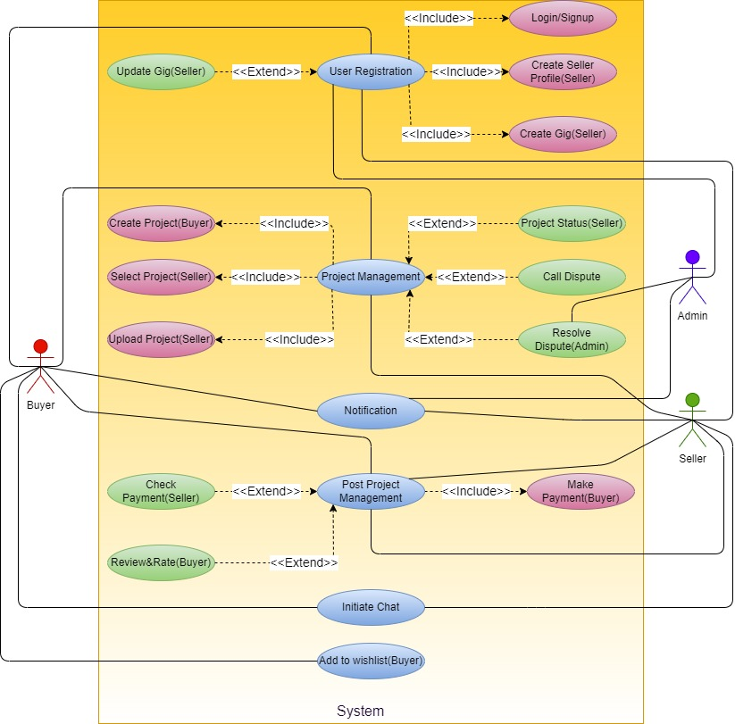

Use Cases Description
Actors:
- Buyer
- Seller

Buyer Use Case:
- Login/Sign Up:
Description: User will login/Sign up using Metamask wallet.
Pre-condition: Seller is not logged in.
Post-condition: Seller gains access to platform features upon successful login or signup.
- Create Seller Profile:
Description: Enables sellers to establish their online presence by providing personal information, skills, and portfolio details.
Pre-condition: Seller is logged in.
Post-condition: Seller's profile is created and visible to potential clients.
- Create Gig:
Description: Allows sellers to define and publish specific services they offer.
Pre-condition: Seller has an active profile.
Post-condition: Gig is created, showcasing seller's expertise and availability.
- Update Gig:
Description: Enables sellers to modify or enhance details of an existing gig.
Pre-condition: Seller has an active gig.
Post-condition: Gig information is updated, reflecting changes in services or terms.
- Check Payment:
Description: Allows sellers to review payment status for completed tasks.
Pre-condition: Task is marked as completed.
Post-condition: Seller views payment details and transaction history.
- Notification:
Description: Informs sellers of relevant updates, such as new job opportunities, gig requests, or messages.
Pre-condition: Seller is logged in.
Post-condition: Seller receives real-time notifications.
- Upload Project:
Description: Enables sellers to submit completed projects to clients.
Pre-condition: Task is marked as completed.
Post-condition: Project is uploaded, awaiting client approval.
- Call Dispute:
Description: Allows sellers to initiate a dispute resolution process in case of conflicts with clients.
Pre-condition: Dispute exists between seller and client.
Post-condition: Dispute resolution process is initiated, facilitating communication and resolution.
Seller Use Case:
- Buyer Login/Signup:
Description: Allows buyers to access the platform by logging in or signing up for a new account.
Pre-condition: Buyer is not logged in.
Post-condition: Buyer gains access to platform features upon successful login or signup.
- Create Project:
Description: Enables buyers to define and post new projects for freelancers.
Pre-condition: Buyer is logged in.
Post-condition: Project is created, visible to freelancers, and ready for selection.
- Review Rate Project:
Description: Allows buyers to assess completed projects, provide feedback, and assign ratings to freelancers.
Pre-condition: Project is marked as completed.
Post-condition: Buyer submits review and rating for the freelancer's work.
- Make Payment:
Description: Enables buyers to release payments for completed tasks or projects.
Pre-condition: Task or project is marked as completed.
Post-condition: Payment is made to the freelancer, and transaction details are updated.
- Call Dispute:
Description: Allows buyers to initiate a dispute resolution process in case of conflicts with freelancers.
Pre-condition: Dispute exists between buyer and freelancer.
Post-condition: Dispute resolution process is initiated, facilitating communication and resolution.
- Initiate Chat:

Description: Enables buyers to start a real-time conversation with freelancers for project discussions.
Pre-condition: Buyer is logged in, and project is created.
Post-condition: Chat session is initiated between the buyer and selected freelancer.
- Add to Wish List:
Description: Allows buyers to save interesting gigs to a wish list for future reference.
Pre-condition: Buyer is logged in.
Post-condition: Gig is added to the buyer's wish list.
- Gig Searching:
Description: Allows buyers to search for specific sellers or gigs based on keywords or criteria.
Pre-condition: Buyer is logged in.
Post-condition: Buyer views relevant freelancers or gigs matching the search criteria.
- Notification:
Description: Informs buyers of relevant updates, project completions, or chat messages.
Pre-condition: Buyer is logged in.
Post-condition: Buyer receives real-time notifications.

Chapter 4

System Design

Chapter 4: System Design

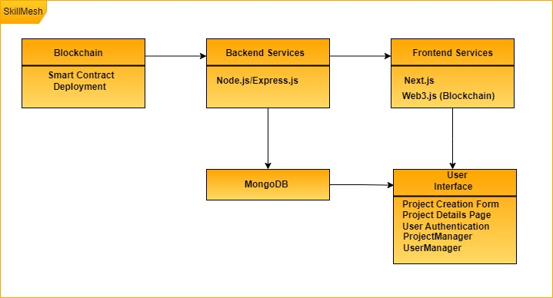

Architecture Diagram
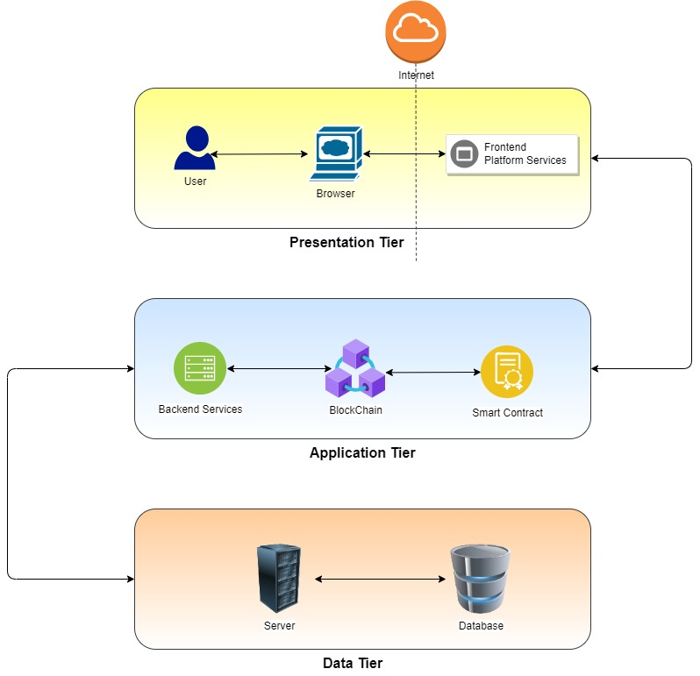

Domain Model
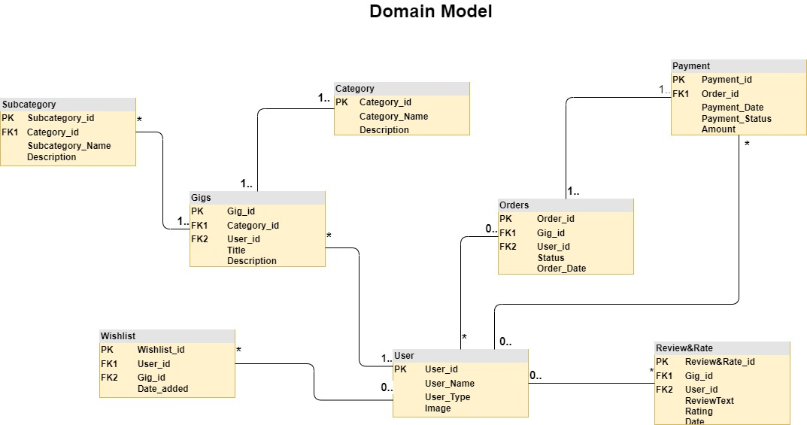

Entity Relationship Diagram with data dictionary

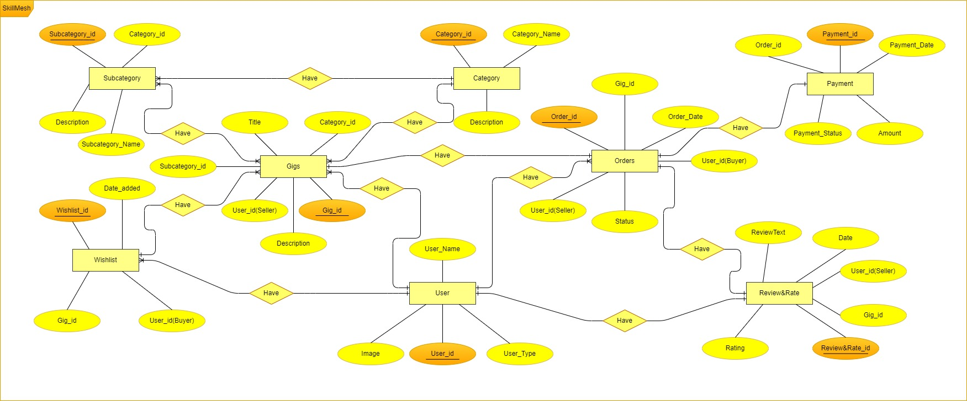

Sequence / Collaboration Diagram
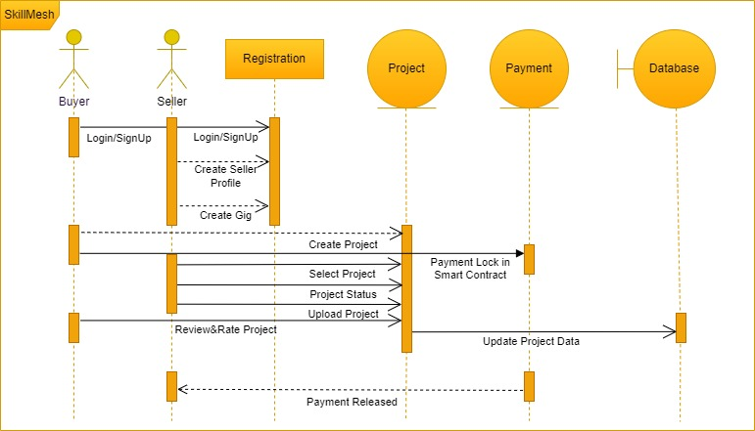

Operation contracts
- User Registration:
  - Operation Contract: registerUser(username, email, password)
  - Description: Registers a new user on SkillMesh.
  - Preconditions: The provided username and email must be unique. The password must meet security requirements.
  - Postconditions: A new user account is created, and the user is logged into the system.

- Create Project:
  - Operation Contract: createProject(title, description, skillsRequired, budget)
  - Description: Allows a client to create a new project on SkillMesh without a bidding mechanism.
  - Preconditions: The user must be authenticated. The project title, description, and skills required must be provided.
  - Postconditions: A new project is created and added to the platform.
- Place Order:
  - Operation Contract: placeOrder(projectId)
  - Description: Enables a client to place an order for a project without a bidding process.
  - Preconditions: The user must be authenticated as a client. The project must be available for ordering.
  - Postconditions: An order is placed for the specified project.
- Accept Order:
  - Operation Contract: acceptOrder(projectId)
  - Description: Allows a freelancer to accept an order placed by a client.
  - Preconditions: The user must be authenticated as the freelancer. The project must be available for accepting orders.
  - Post conditions: The freelancer is notified, and the project status is updated.

- Process Payment:
  - Operation Contract: processPayment(projectId)
  - Description: Initiates the payment process for a completed project.
  - Preconditions: The project status must be marked as completed by both the client and freelancer.
  - Post conditions: Payment is processed, and the freelancer is compensated according to the agreed terms.
- Resolve Dispute:
  - Operation Contract: resolve Dispute(projectId, resolutionDetails)
  - Description: Allows users to resolve disputes related to a project.
  - Preconditions: A dispute must be initiated by either the client or freelancer.
  - Post conditions: The dispute is resolved, and the project status is updated accordingly.
- Update User Profile:
  - Operation Contract: updateUserProfile(userId, newDetails)
  - Description: Allows users to update their profile information.
  - Preconditions: The user must be authenticated. Valid updated details must be provided.
  - Post conditions: The user's profile information is updated

Activity Diagram
Buyer Activity
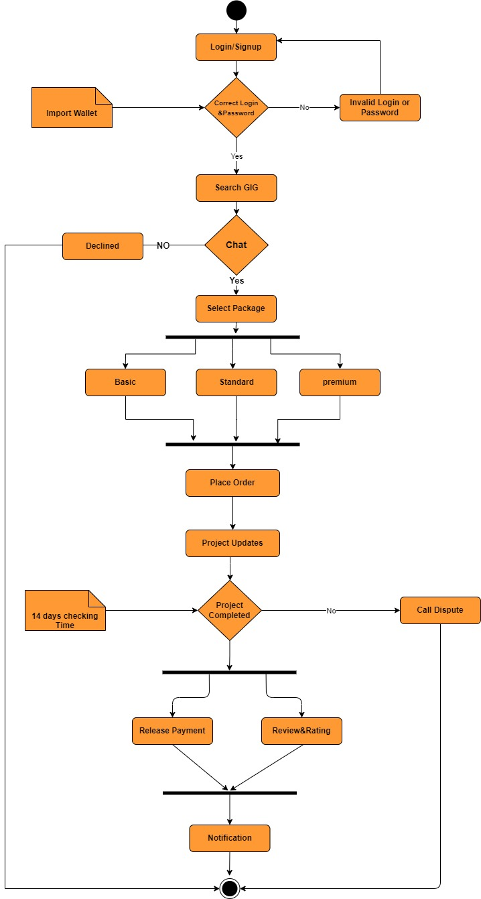

Seller Activity
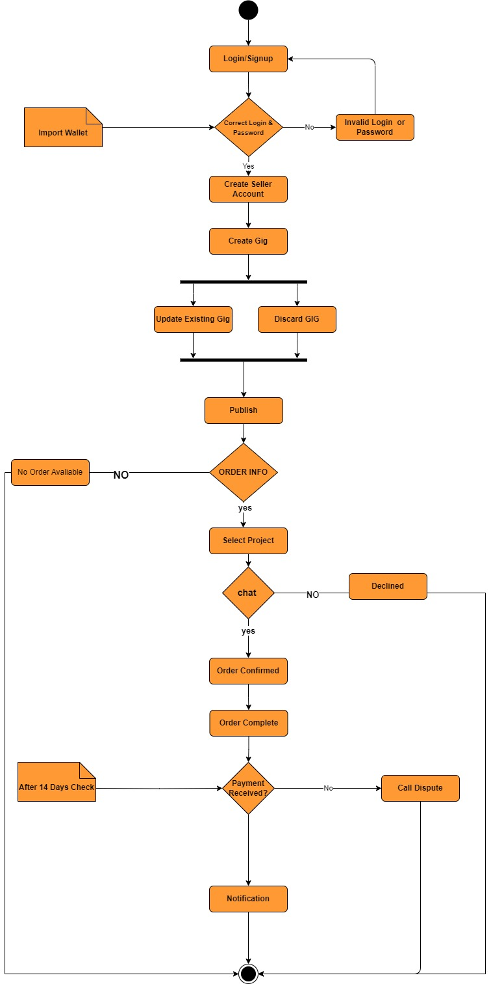

State Transition Diagram
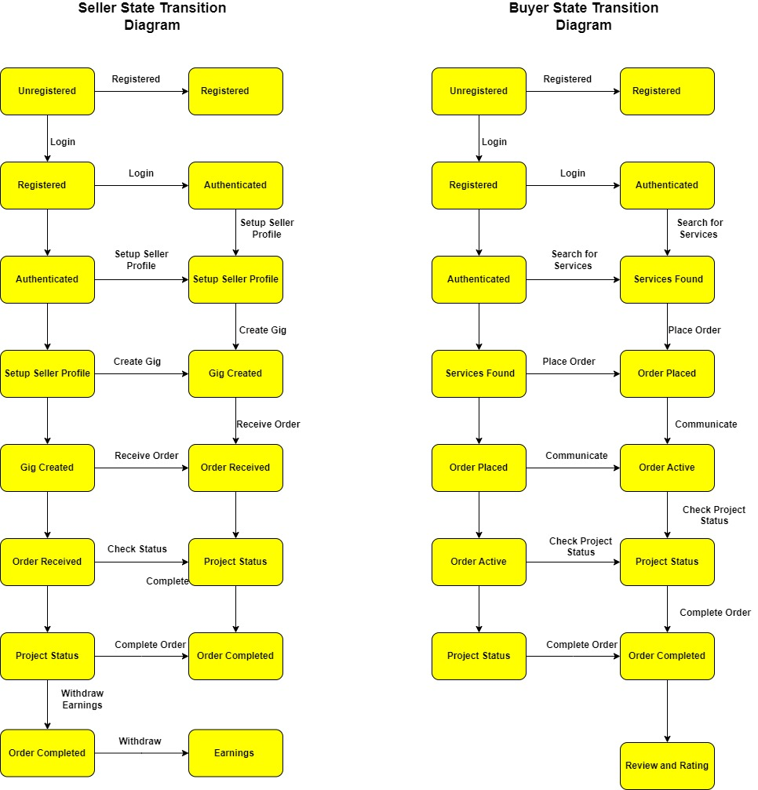

Component Diagram
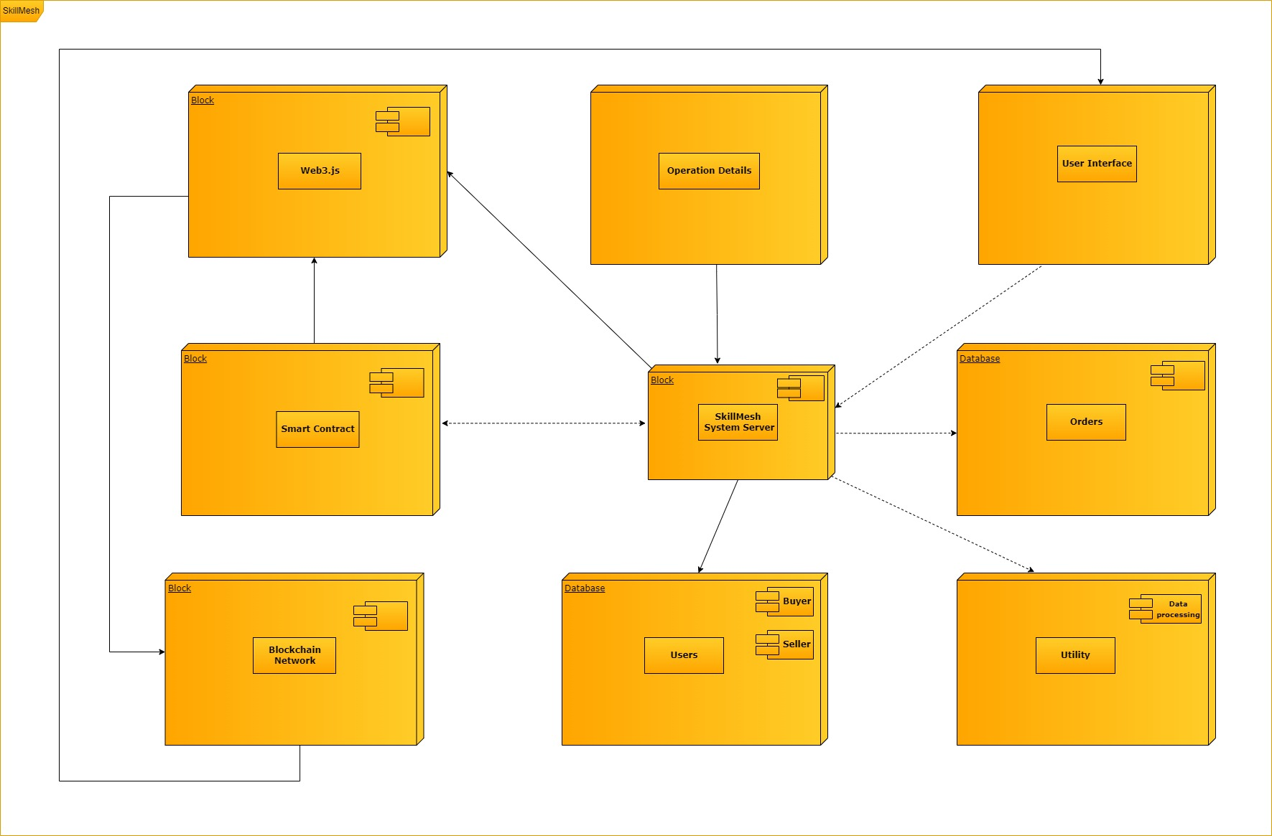

Deployment Diagram
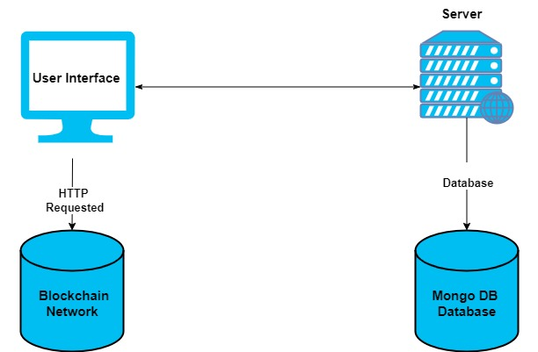

Data Flow diagram [only if structured approach is used - Level 0 and 1]
Level 0

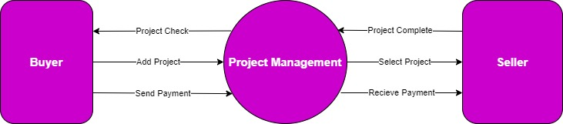

Level 1
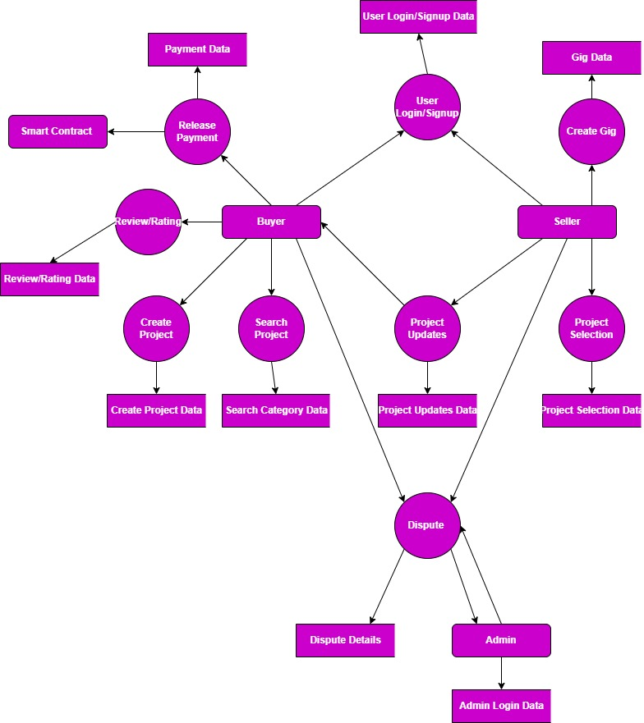
Level 2
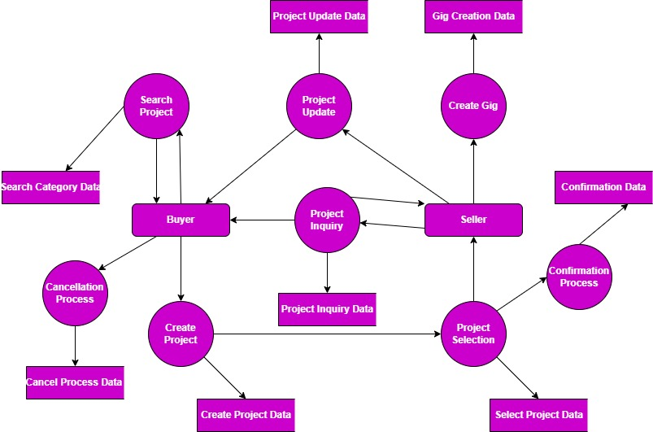

Chapter 5

Implementation

Chapter 5: Implementation
The implementation of SkillMesh, a decentralized freelancing platform, involves several key steps. First, the development environment is set up by choosing a blockchain platform, installing necessary tools, and creating a local blockchain node. Smart contract development follows, where logic is defined, contracts are implemented, and rigorous testing and security audits are conducted. Blockchain integration includes decentralized identity solutions, token implementation, and oracles integration.
On the frontend, a framework like Next.js is chosen, and user interfaces are designed for a seamless experience. Web3.js (Blockchain) is integrated for communication with smart contracts. The backend, powered by Node.js and Express.js, handles server-side logic and integrates MongoDB for data storage. Security measures are implemented at both the server and smart contract levels.
Deployment involves choosing a cloud provider, deploying smart contracts to the blockchain, and hosting the frontend and backend components. DNS configurations and SSL certificates are set up for secure communication. Testing includes unit and integration testing to ensure the functionality and communication between components.
Ongoing monitoring and maintenance involve integrating tools for tracking performance and user activity. Regular maintenance, including updates and security patches, is crucial. User feedback is collected for iterative improvements to the platform.

In Summary, SkillMesh implementation blends smart contract development, Blockchain integration, frontend and backend development, deployment, testing, and ongoing maintenance.

Important Flow Control/Pseudo codes
[Paragraph Text 12 pt, Calibri, 1.5 Line Spacing, Justified]

Components, Libraries, Web Services and stubs

Library: web3.js, uPort, SelfKey, MongoDB, Solidity, React Router
Framework: Next.js or Node.js with Express.js
dependencies": {
"@chakra-ui/react": "^2.8.1",
"@mui/icons-material": "^5.14.19",
"@react-spring/parallax": "^9.7.3",
"@reduxjs/toolkit": "^1.9.7",
"emoji-picker-react": "^4.5.6",
"framer-motion": "^10.16.4",
"infinite-react-carousel": "^1.2.11",
"next": "^14.0.3",
"react": "latest",
"react-dom": "latest",
"react-icons": "^4.11.0",
"react-redux": "^8.1.3",
"react-toastify": "^9.1.3"
}

Deployment Environment
To deploy SkillMesh, a decentralized freelancing platform, a comprehensive environment is established that seamlessly integrates blockchain technology, cloud services, and essential backend and frontend components. The chosen blockchain network, such as Ethereum serves as the foundation for deploying smart contracts that govern the platform's core functionalities. Cloud service providers like AWS, Azure, or GCP offer scalable infrastructure, with virtual servers configured to host the backend (Node.js and Express.js) and frontend (Next.js) components. MongoDB, a NoSQL database, is integrated for efficient data storage and retrieval.

Security measures, including firewalls and SSL, are implemented to safeguard user data and interactions. The SkillMesh platform interacts with the blockchain through a connected node, facilitating transactions and smart contract executions. Monitoring tools track server performance and user activities, providing insights for optimization. DNS configurations and SSL certificates are set up for domain mapping and secure communication. Continuous Integration/Continuous Deployment (CI/CD) pipelines automate testing and deployment processes, ensuring a streamlined development workflow. Regular backup procedures and recovery plans are established to maintain data integrity and system resilience. This deployment environment ensures SkillMesh secure, scalable, and reliable operation as a decentralized freelancing solution.

Tools and Techniques
No | Tools | Techniques
1. | Next.js | Creating a responsive and intuitive user interface, integrating Web3.js for blockchain communication, and utilizing Next Router for navigation.
2. | Node.js, Express.js | Server-side logic development, MongoDB for data storage, and integrating security measures such as firewalls and SSL.
3. | Git, GitHub | Using Git for version control, facilitating collaborative development, and ensuring effective communication among development teams.
4. | GitLab CI/CD | Setting up CI/CD pipelines for automated testing and deployment, ensuring a streamlined development workflow.
5. | Remix, Truffle, Ganache | Solidity for smart contract development, Web3.js for interacting with the blockchain, and testing frameworks like Truffle for ensuring smart contract functionality.
6. | uPort, SelfKey | Implementing decentralized identity solutions for secure and privacy-focused user authentication.
7. | IPFS (Interplanetary File System), Infura | Leveraging IPFS for decentralized storage, using Infura for Ethereum node access, and integrating Firebase Authentication for secure user authentication.

Best Practices / Coding Standards
SkillMesh adheres to industry-best practices and coding standards to ensure maintainability, scalability, and readability of codebase. Following the Model-View-Controller (MVC) architectural pattern, the code is organized into distinct components for efficient development and future enhancements.
Best Practices and Coding Standards:
1. Solidity Smart Contracts:
- Contracts follow the Solidity style guide and are well-commented for clarity.
- Code is modular, promoting reusability and separation of concerns.
- Security considerations, such as avoiding reentrancy vulnerabilities, are addressed.
2. Node.js and Express.js Backend:
- Code adheres to the JavaScript Standard Style, ensuring consistency.
- Express.js middleware is used for tasks such as request parsing and error handling.
- RESTful API endpoints follow naming conventions and are designed with simplicity and clarity in mind.
3. Next.js Frontend:
- Components follow the JSX and ES6 syntax, enhancing code readability.
- State management is handled efficiently using Next.js state and props.
- Code is organized into reusable and maintainable components
4. Database Interaction (MongoDB):
- MongoDB queries are written in a concise and readable manner.
- Connection handling follows best practices, including connection pooling and error handling.
5. Blockchain Integration (Web3.js):
- Web3.js code is structured for easy interaction with the Ethereum blockchain.
- Smart contract interactions are encapsulated in well-defined functions, enhancing code maintainability.

6. MVC Model Pattern:
- Model (Smart Contracts):
  - Represents the data and logic of SkillMesh projects.
  - Manages the state and rules for creating and completing projects.
- Next.js (Frontend):
  - Renders the user interface, presenting data from the backend to users.
  - React components are organized hierarchically to encapsulate views.
- Controller (Express.js Backend):
  - Manages the flow of data between the model and the view.
  - Handles business logic, including project creation and completion.

Version Control
Version control is a critical aspect of SkillMesh development lifecycle, providing a systematic approach to managing code changes, collaborating among developers, and ensuring the stability of the codebase. SkillMesh uses Git as its version control system, employing best practices to streamline development workflows and facilitate collaboration.
Key Version Control Practices:
1. Git Repository:
- The SkillMesh codebase is hosted in a central Git repository, providing a single source of truth for the project.
2. Branching Strategy:
- A branching strategy is in place to manage different aspects of development.
- main Branch: Represents the production-ready code.
- development Branch: Integrates feature branches for ongoing development.
- Feature Branches: Created for each new feature or enhancement, ensuring isolation and easy integration.
3. Commit Messages:
- Descriptive and meaningful commit messages are used to explain the purpose of each commit clearly.
- Follows the conventional commit format for consistency.

4. Pull Requests (PRs):
- Feature branches are merged into the development branch through pull requests.
- Pull requests include a summary of changes, any related issues, and are reviewed by peers before merging.
5. Continuous Integration (CI):
- CI pipelines are configured to run automated tests on each pull request.
- Ensures that new code changes do not introduce regressions or errors.
6. Tagging Releases:
- Releases are tagged in Git to mark specific points in the project's history.
- Follows semantic versioning to convey the nature of changes.
7. Git Hooks:
- Pre-commit and pre-push Git hooks are utilized to enforce code quality checks, ensuring only high-quality code is committed.
8. Code Review:
- Code reviews are an integral part of the version control process.
- Peers review each other's code to catch bugs, ensure adherence to coding standards, and share knowledge.
9. Gitignore:
- A well-maintained .gitignore file excludes unnecessary files and directories from version control, optimizing repository size.
10. Git Flow Documentation:
- The project includes documentation on the Git Flow used, detailing the branching model and the process for handling releases and hotfixes.

Appendices

Appendix A: Information / Promotional Material

  - Broacher

  - Flyer

  - Standee

  - Banner

  - First Level heading [16 pt, Calibri, Bold, Left aligned]
[Paragraph Text 12 pt, Calibri, 1.5 Line Spacing, Justified]

    - Second level heading [14 pt, Calibri, Bold, Left aligned]
[Paragraph Text 12 pt, Calibri, 1.5 Line Spacing, Justified]

      - Third level heading [12 pt, Calibri, Bold, Left aligned]
[Paragraph Text 12 pt, Calibri, 1.5 Line Spacing, Justified]

Appendix [no.]: Appendix Title
[Paragraph Text 12 pt, Calibri, 1.5 Line Spacing, Justified]
[Between 4 to 8 lines describe what is this chapter all about]

  - First Level heading [16 pt, Calibri, Bold, Left aligned]
[Paragraph Text 12 pt, Calibri, 1.5 Line Spacing, Justified]

    - Second level heading [14 pt, Calibri, Bold, Left aligned]
[Paragraph Text 12 pt, Calibri, 1.5 Line Spacing, Justified]

      - Third level heading [12 pt, Calibri, Bold, Left aligned]
[Paragraph Text 12 pt, Calibri, 1.5 Line Spacing, Justified]

Reference and Bibliography

Reference and Bibliography

[1] M. Sher, M. Rehman, “Title of the Paper” Conference name/Journal Name, Edition, Volume, Issue, ISBN/ISSN, PP, Publisher/City-Country, Year.
[2] ……

Index

Index

[A]

[B]

[C]

